## horizontal line



CFC Vizathon Entry

13.04.2025

**─**

Thomas Aston ([thomas.aston@ed.ac.uk](mailto:thomas.aston@ed.ac.uk))

# Overview

This document summarises the key features for my entry into the CFC Performance Insights Vizathon. The dashboard presented in this document was developed primarily in Python using the Dash package.

A live, interactive version of my entry can be found at: <https://ta-cfc-vizathon.onrender.com/>

Please note that due to being hosted on the free tier of render (<https://render.com/>) which comes with limited CPU resources and no background workers, dashboard page and plot loading can be slow at times.

The source code and data files for this project can be found at: <https://github.com/ThomasAston/CFC-Vizathon>

The data used to create the interactive visualisations in this dashboard is a combination of real-world football data from the 2023/2024 season from API-football (<https://www.api-football.com/>) (used to create the squad lists and player biographies, including radar plot comparisons of their per 90 minute match stats for the season), as well as the reference data provided by CFC (used to create the Load Demand, Physical Development and Recovery modules), and mock data (used to create the Injury History and External Factors modules).

The key features of the dashboard are highlighted on the following pages, but to see the complete functionality of the platform it is recommended to watch the attached video or to interact with the dashboard online.

# 

# Key Features

## Landing Page Features

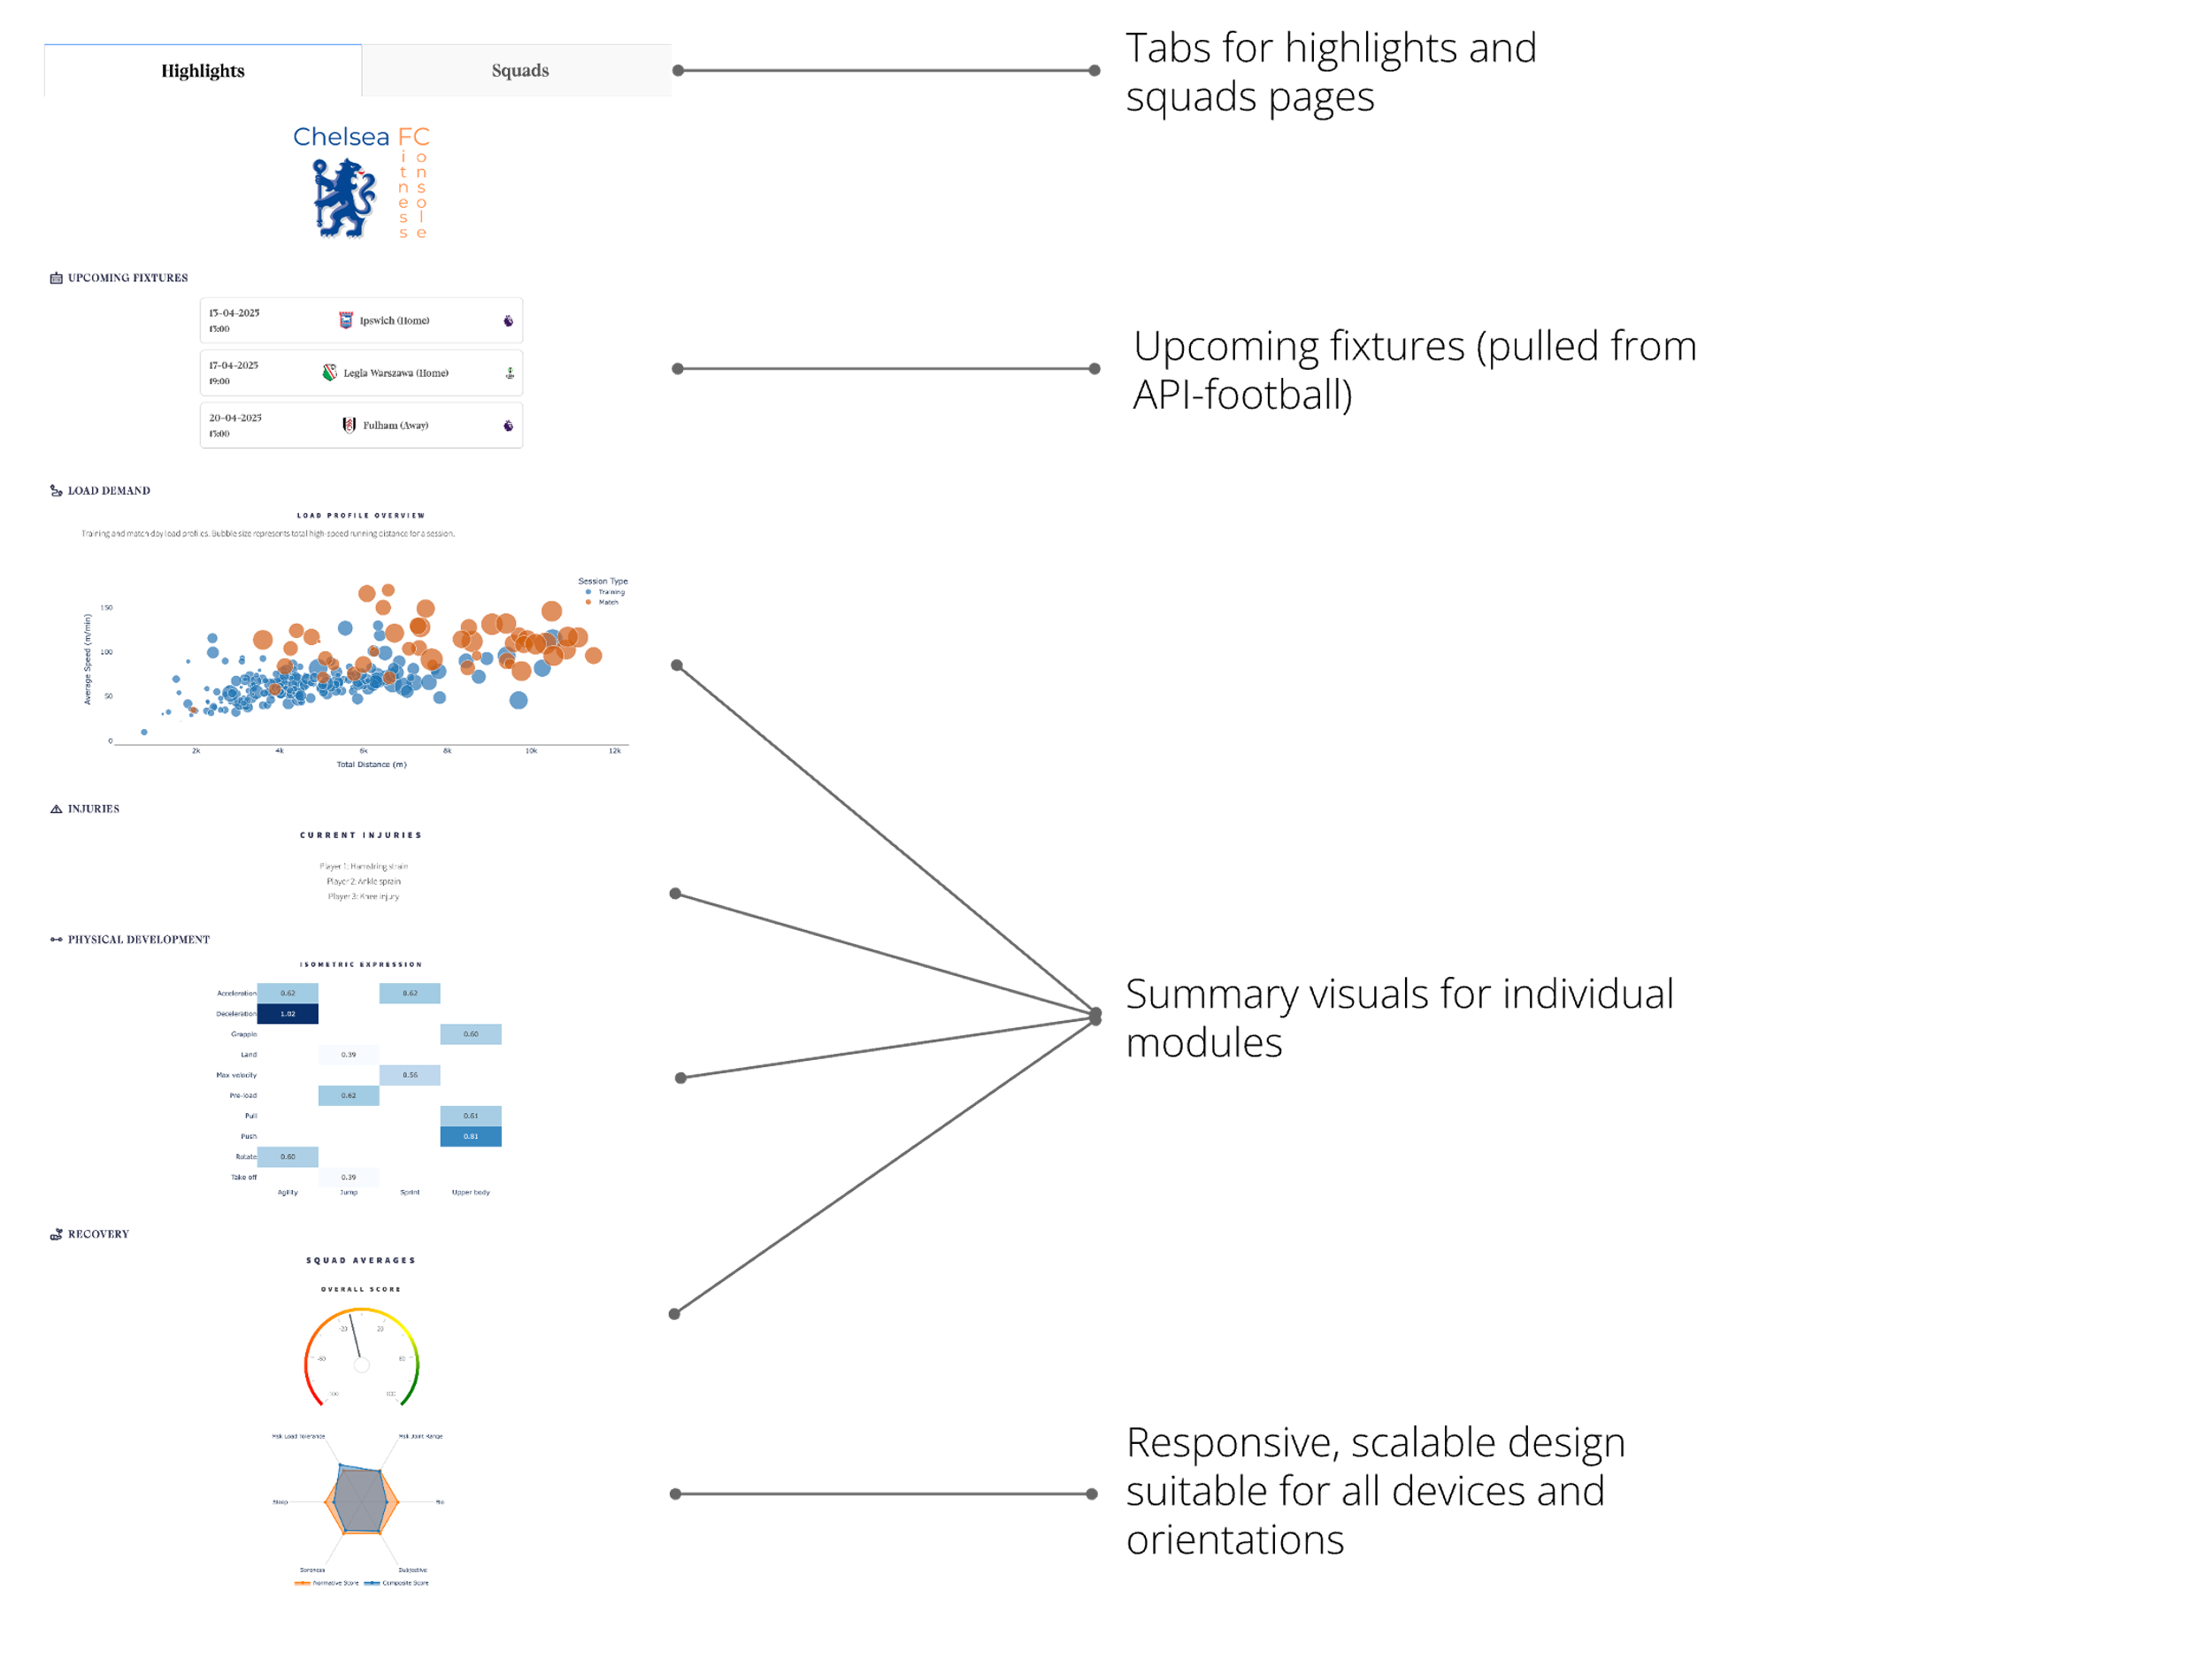

## Squads Page Features

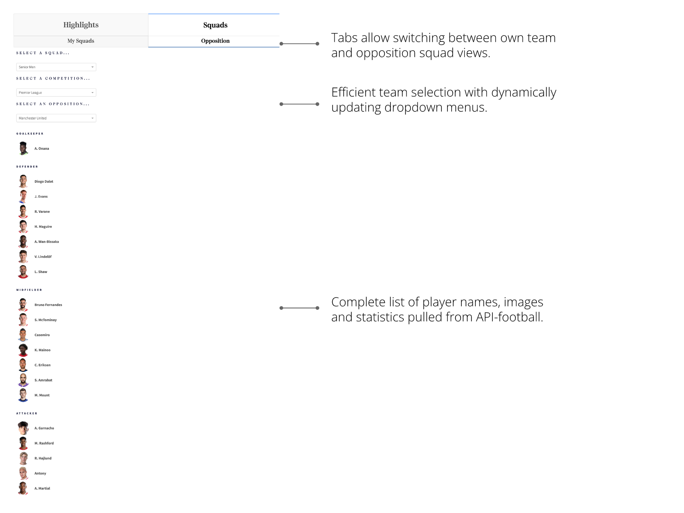

## Load Demand Features

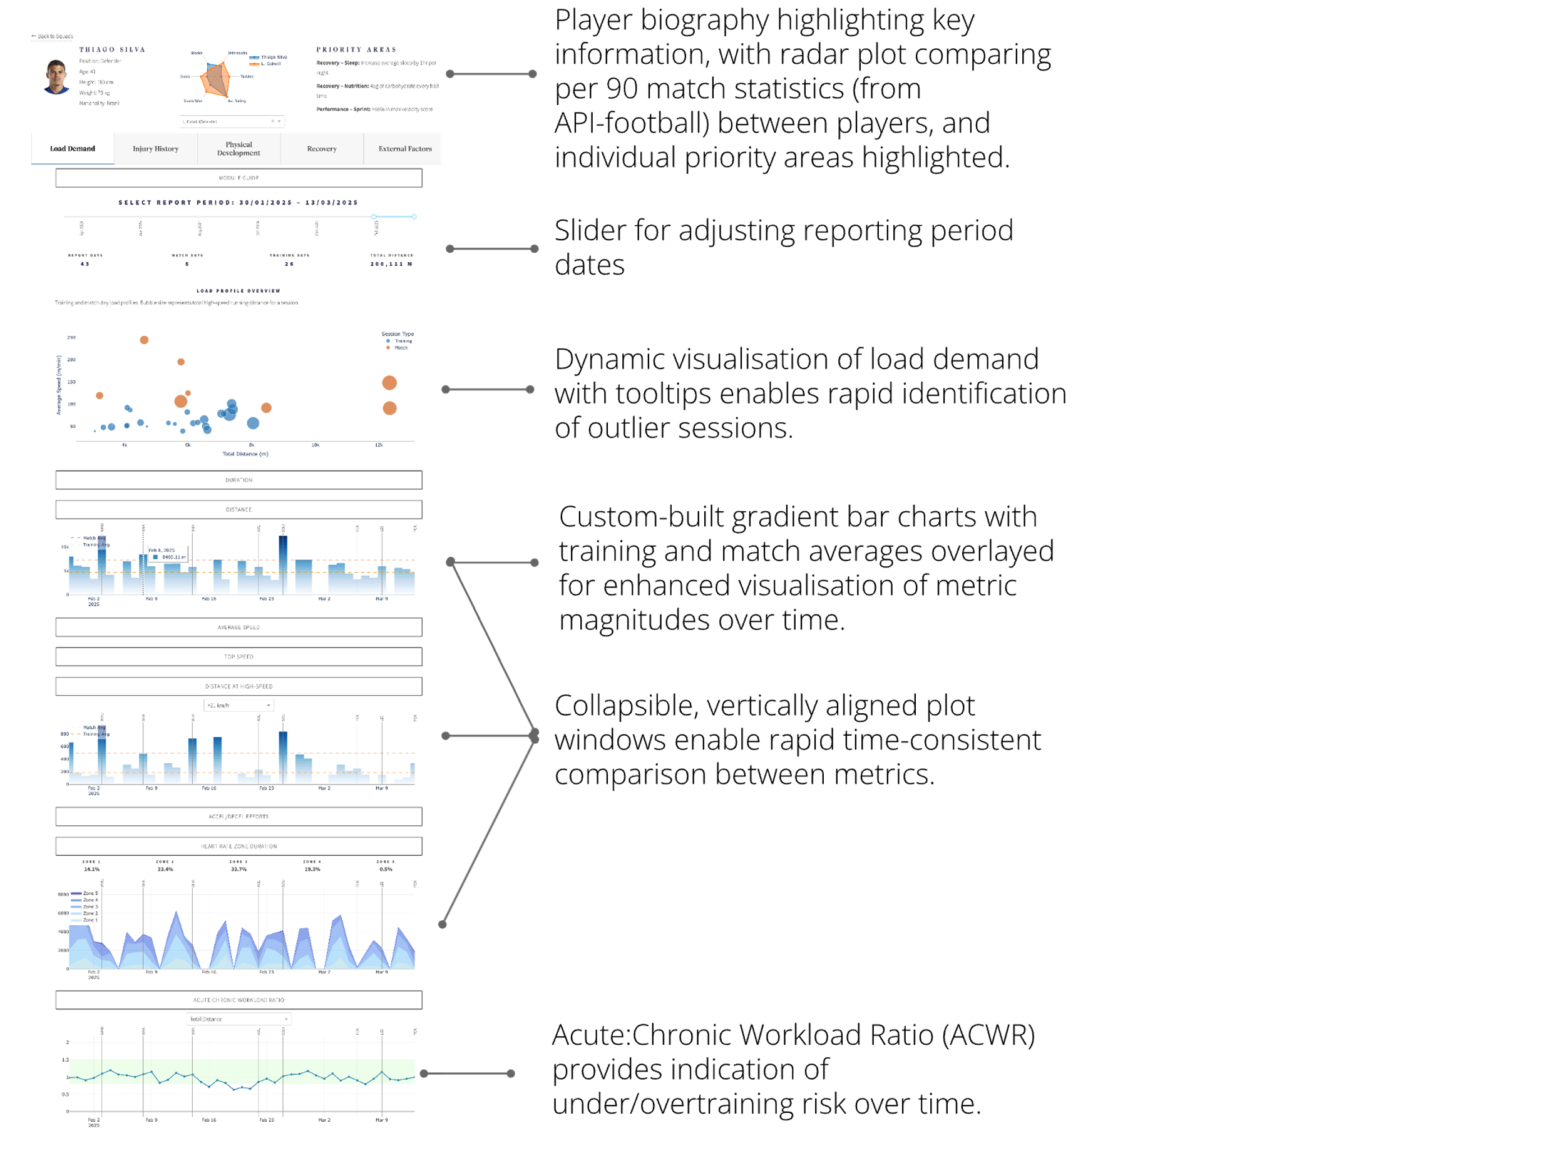

Physical Development Features

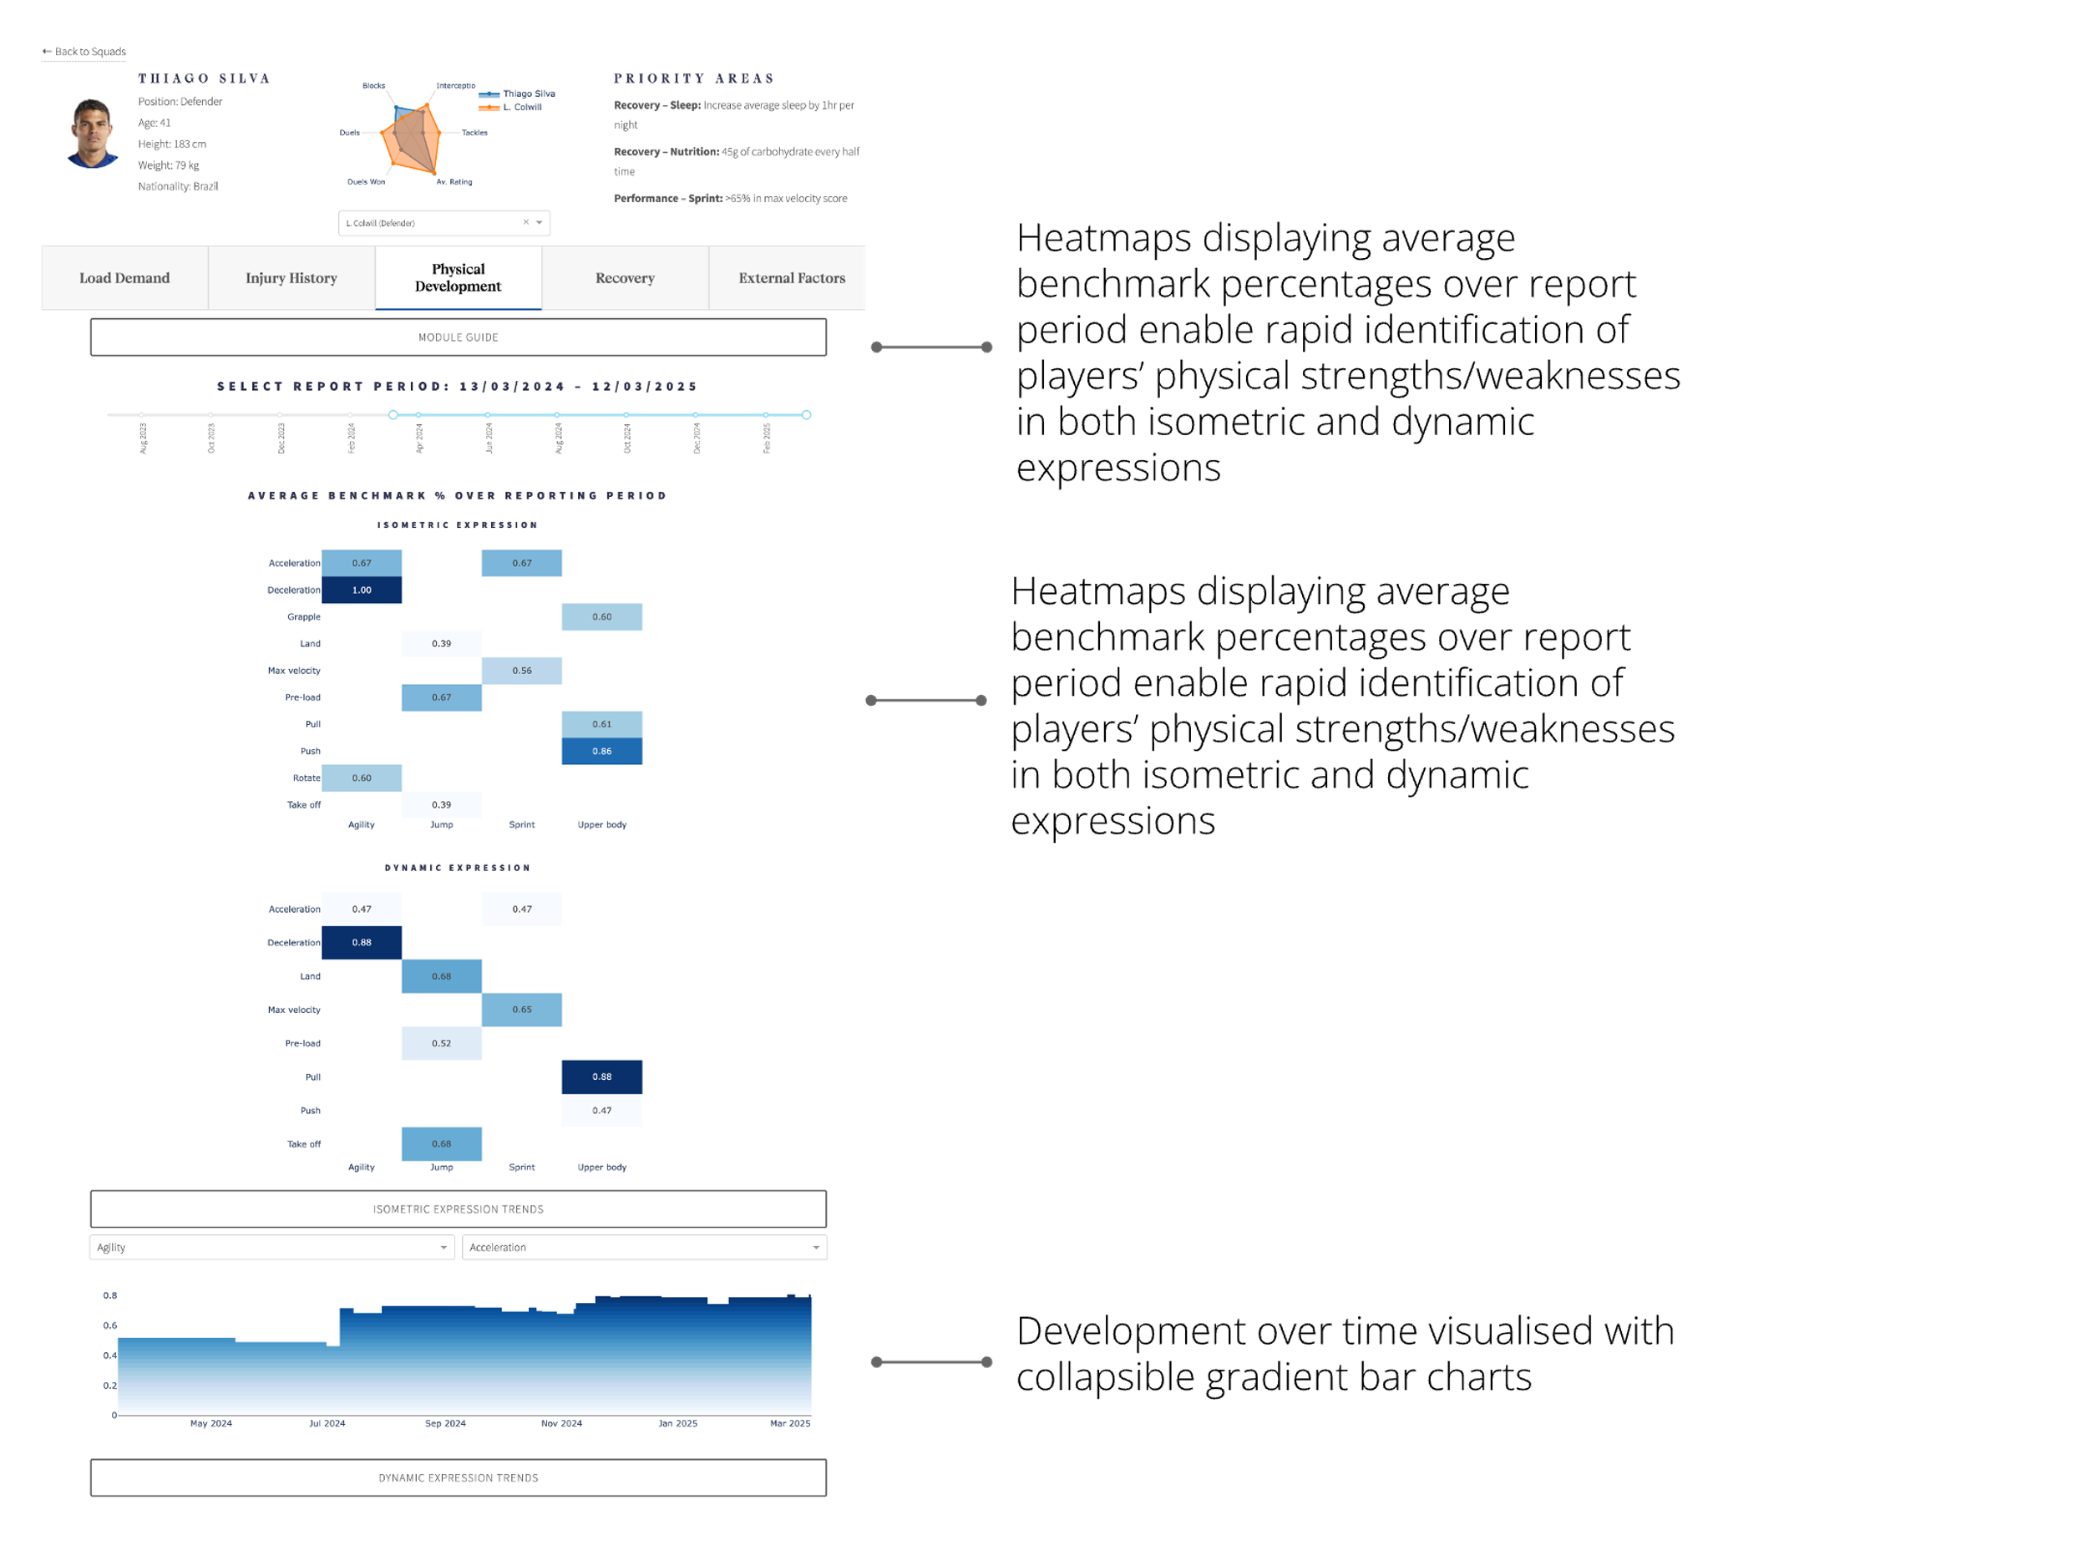

## 

## Recovery Features

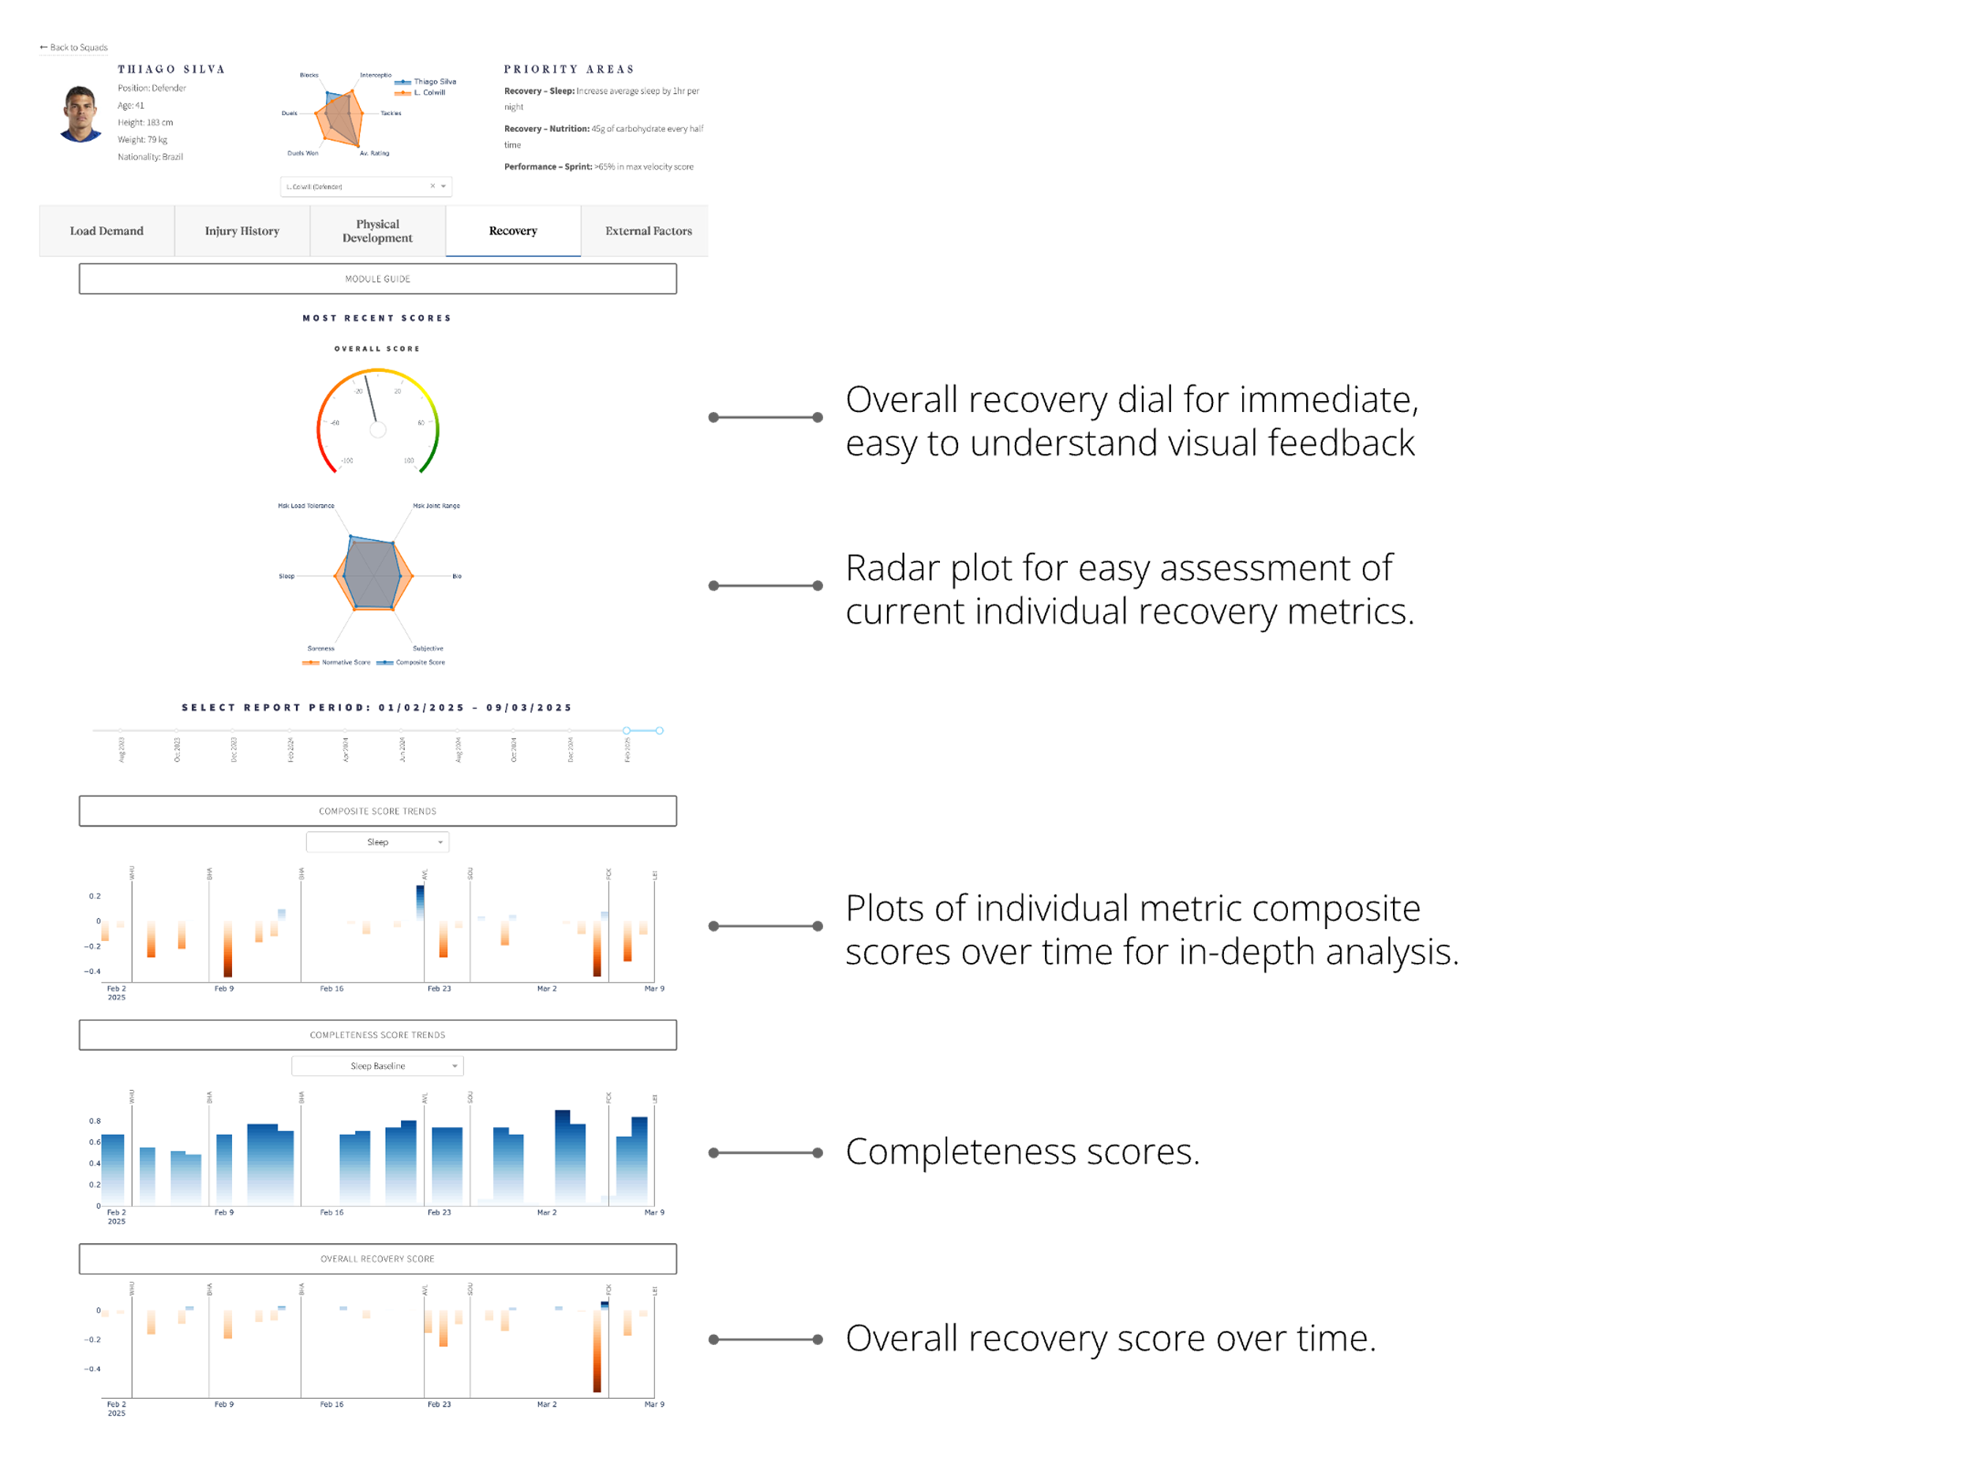

## Injury History Features

